**Experiment No : 8**

**Name : Rajashri Jaywant Patil**

**Title:-PL/SQL block on branching and looping statement .**

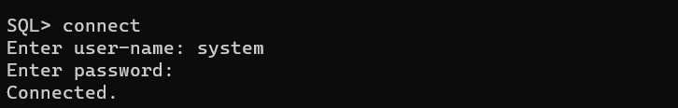

**PL/SQL IF THEN statement**

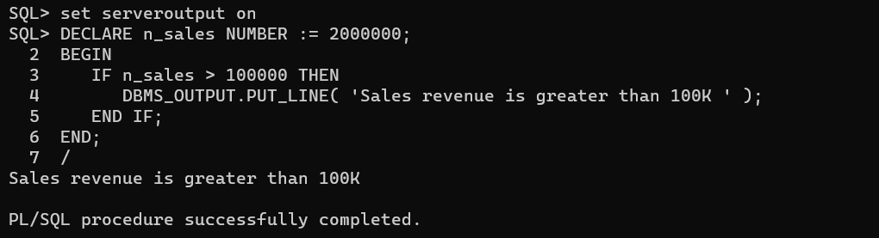

**PL/SQL IF THEN ELSE statement**

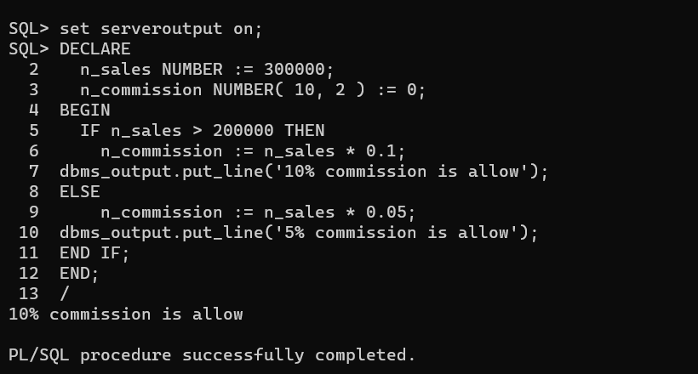

**PL/SQL LOOP statement**

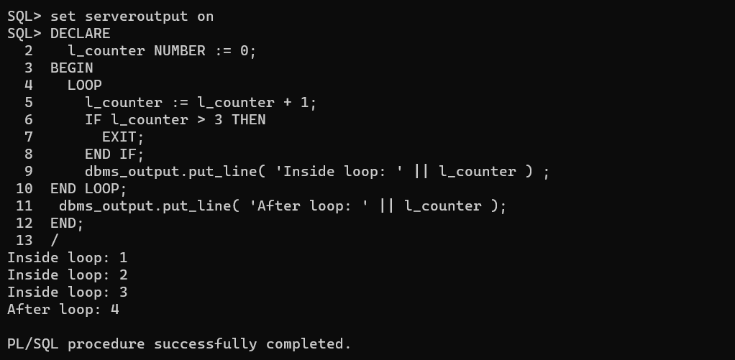

**PL/SQL FOR LOOP statement**

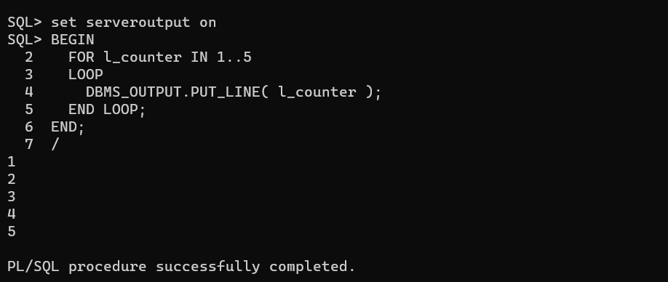

**PL/SQL CASE statement**

